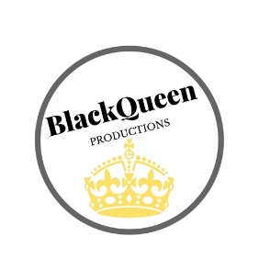
2019
BlackQueen Productions
Las Vegas, NV
Dear Potential Sponsor,
I proudly represent the prestigious Western US and Nevada American Elegance pageant, and I’m part of the team responsible for our event’s success. We’re hosting our 3rd annual Nevada and Western US American Elegance beauty pageant. This event not only helps raise funds for, Inspiring Trees of Hope (a cancer relief and assistance charity) but it will also raise awareness of beauty diversity, women’s equality, and positive female community influences.
We’re proud to announce that this year’s event will be held on Friday and Saturday, August 24th and 25th at the Tuscany Resort and Casino in Las Vegas, Nevada.
Since the event’s inception, we’ve produced many events that promote positivity and mentorship for young girls as well as participants that have been able to travel and win National beauty competitions with the American Elegance organization as it goes into its 20th year! We host girls 1-18 yrs old and women of any age, including women well into their late sixties. Our titleholders can be seen all over the country, reading to groups, volunteering with marathons, participating in benefit walks and creating fundraisers for groups such as BullyBusters702, Shade Tree, WeRoc Las Vegas, Common Tree, and St. Jude’s Ranch
We are expecting approximately 25 participants this year and could use your assistance for us to produce prizes, coaching sessions, catered meals, and provide scholarships for women that would not normally be able to afford a pageant experience. We pride ourselves on being the most diverse pageant system in regards to recruiting women that are of any age, and size, any culture and any marital status. Most large and national systems only recruit women of certain demographics, have age cut offs, and do not allow plus size women to compete.
Every year, this event wouldn’t be possible without the support of local companies who provide valuable products, services and ads, so that we can support participants during the event.
Would you be willing to sponsor an advertisement page in our program book to help make this year’s event possible? The ads are full color and are distributed to all attendees. Our events are well attended from 100-200 people and our participants come from various states including, Nevada, California, Oregon, Washington, Utah, Arizona, Idaho, and New Mexico.
If you wish to support us, I would be happy to provide you with more information.
Thank you for your consideration! With your help, we’re one step closer toward a fantastic event.
Sincerely,
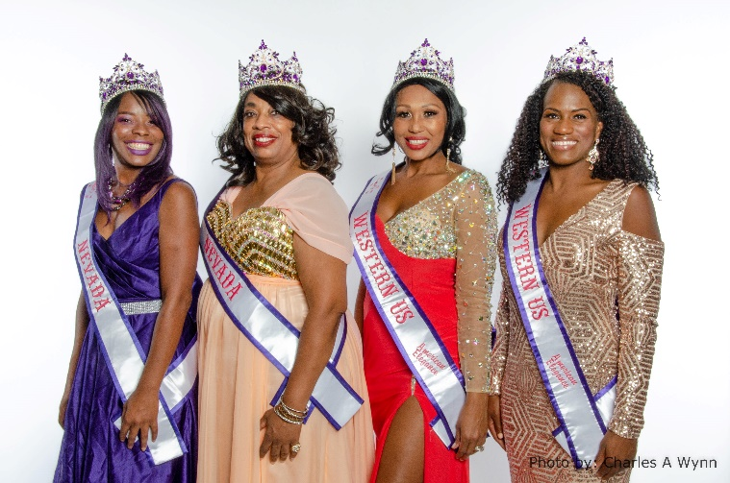
Jennece Black
Owner & CEO
Contact Agent:_________________________________________________
E:mail: aenevadainfo@gmail.com
Website: www.nvamericanelegance.com
Diamond Sponsorship Level ($50)
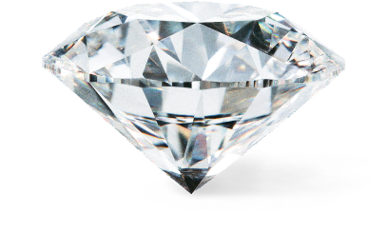
• Company name, logo, and sponsorship level listed in event programming and/or promotional materials [promotional materials might include flyers, pamphlets, program book, or t-shirts].
• Company included on “Partner’s Page” website for 1 year, with link if applicable
• Social media shout out a week before and after the event has ended
• Two tickets to the event
• Autographed Queens and Princess framed photo.
Ruby Sponsorship Level ($75)
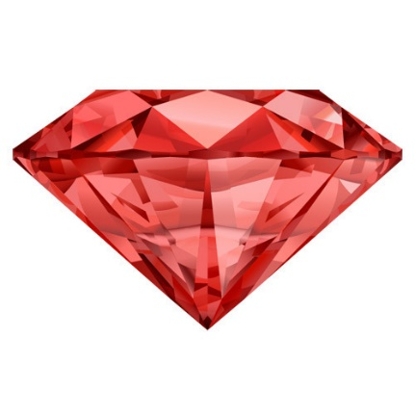
• Company name, logo, and sponsorship level listed in event programming and/or promotional materials [promotional materials might include flyers, pamphlets, program book, or t-shirts].
• Company included on “Partner’s Page” on website for 2 years
• 3 social media shout outs before and after the event
• Three tickets to the event
• ½ Page advertisement in program book for at least 100 copies
• Autographed Queens and Princess framed photo
Emerald Sponsorship Level ($120)
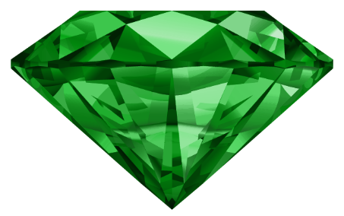
• Company name, logo, and sponsorship level listed in event programming and/or promotional materials [promotional materials might include flyers, pamphlets, program book, or t-shirts].
• Company included on “Partner’s Page” on website for 2 years
• Ongoing social media shout outs from sign up (10 total before and after the event)
• Four tickets to the event with VIP seating
•FULL Page advertisement in program book for at least 100 copies
• A live shout out/acknowledgement during the event and queen’s volunteer day at your discretion
• Autographed Queens and Princess framed photo
—————————————————————————————————————————
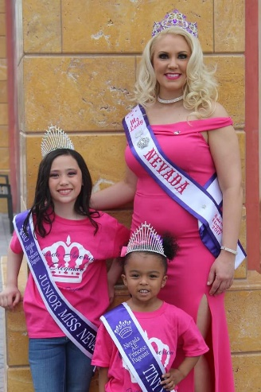
Please indicate your preferred sponsorship level, fill out the rest of this form, and mail it back in the self addressed envelope we’ve included with a check or money order made to: BLACKQUEEN PRODUCTIONS Paypal accepted: aenevadainfo@gmail.com
Name and Position: __________________________________________
Company Name: _____________________________________________
Email Address: ________________________________________________
Phone Number: _______________________________________________
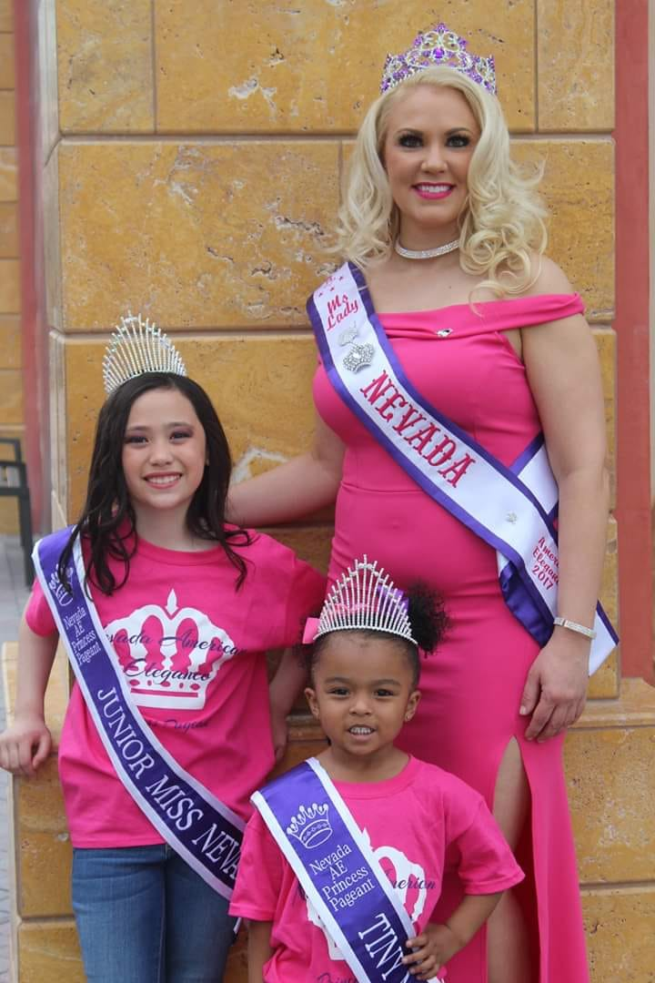
Select a Sponsorship Level:  Diamond  Ruby  Emerald

